Institutional Affiliation

Professor's Name

Student's Name

Date

EXERCISE

- False
- True
- False
- True
- False

- 8 comparisons, not found
- 6 comparison
- 1 comparison
- 8 comparisons, not found
- ,
- Sequential search searches for elements sequentially up to search elements is less than element in the list, but does not compare the elements from the list. Compare that search element whether it is greater than each element in the list until it reaches less than or no element in the list. Compare that search element with that element in the list if equal, element is found, if not equal, exits the operation.

An example is shown below;

#include <iostream>
using namespace std;

int binarySearch(int[], int, int, int);

int main()
{
int num[11] = {5,12,17,35,46,65,78,85,93,110,115};
int search_num, loc=-1;

cout<<"Enter the element that you want to search: ";
cin>>search_num;

loc = binarySearch(num, 0, 6, search_num);

if(loc != -1)
{
cout<<search_num<<" found in the array at the location: "<<loc;
}
else
{
cout<<"Element not found";
}
return 0;
}

int binarySearch(int a[], int first, int last, int search_num)
{
int middle;
if(last >= first)
{
middle = (first + last)/2;
//Checking if the element is present at middle loc
if(a[middle] == search_num)
{
return middle+1;
}

//Checking if the search element is present in greater half
else if(a[middle] < search_num)
{
return binarySearch(a,middle+1,last,search_num);
}

//Checking if the search element is present in lower half
else
{
return binarySearch(a,first,middle-1,search_num);
}

}
return -1;
}

- ,,
- Element found35. The key comparisons are 3
- Element found 60. The key comparisons are 5
- Element found78. The key comparisons are 6
- Element not found 120. The key comparisons are 11

- ..
- Comparisons 2
- Comparisons 4
- Comparisons 9
- Comparisons 11
- Bubble Sort
#include<iostream>
using namespace std;
int main ()
{
int i, j,temp,pass=0;
int a[8] = {26,45,17,65,33,55,12,18};
cout <<"Unsorted Input list ...\n";
for(i = 0; i<8; i++) {
cout <<a[i]<<"\t";
}
cout<<endl;
for(i = 0; i<8; i++) {
for(j = i+1; j<8; j++)
{
if(a[j] < a[i]) {
temp = a[i];
a[i] = a[j];
a[j] = temp;
}
}
pass++;
}
cout <<"\nSorted Element List ...\n";
for(i = 0; i<8; i++) {
cout <<a[i]<<"\t";
}
cout<<"\n\n\nNumber of passes taken to sort the list:"<<pass<<endl;
return 0;
}
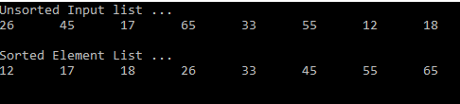

- Selection Sort Algorithm
#include<iostream>
using namespace std;
int findSmallest (int[],int);
int main ()
{
int myarray[10] = {36,55,17,35,63,85,12,48,3,66};
int pos,temp,pass=0;
cout<<"\n The list of elements to be Sorted\n";
for(int i=0;i<10;i++)
{
cout<<myarray[i]<<"\t";
}
for(int i=0;i<10;i++)
{
pos = findSmallest (myarray,i);
temp = myarray[i];
myarray[i]=myarray[pos];
myarray[pos] = temp;
pass++;
}
cout<<"\n\n\n Sorted list of elements is\n";
for(int i=0;i<10;i++)
{
cout<<myarray[i]<<"\t";
}
cout<<"\n\n\nNumber of passes required to sort the array: "<<pass;
return 0;
}
int findSmallest(int myarray[],int i)
{
int ele_small,position,j;
ele_small = myarray[i];
position = i;
for(j=i+1;j<10;j++)
{
if(myarray[j]<ele_small)
{
ele_small = myarray[j];
position=j;
}
}
return position;
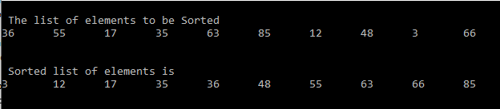
}

- ..
One comparison
- .
One Comparison

- ..
10 18 21 25 28 12 30 71 32 58 15

- ..
Number of Key Comparisons is 25

- ..
Bubble Sort
List of elements n=10, 000
n(n-1) /2

- {10000(10000-1) }/2
- {10000(9999)}/2
- {10000 x 9999 }/2
- 49,995,000 comparisons

Insertion Sort
n=10000
(n²+3n-4) /4 is the formula
{(10000)2 + 3(10000) -4} /4
=> 100000000 + 30000-4
=>100029996
=>100029996/4
=>25,007,499 Comparisons
Selection Sort
Similar to bubble sort
n(n-1) /2 is formula

- {10000(10000-1) }/2
- {10000(9999)}/2
- {10000 x 9999 }/2
- 49,995,000 comparisons

- .. Iterations using Bubble sort

// Function of Bubble Sort.
void BubbleSort (int arr[], int n)
{
int i, j;
for (i = 0; i < n; ++i)
{
for (j = 0; j < n-i-1; ++j)
{
// Comparison in iteration. No swaping.
if (arr[j] > arr[j+1])
{
arr[j] = arr[j]+arr[j+1];
arr[j+1] = arr[j]-arr[j + 1];
arr[j] = arr[j]-arr[j + 1];
}
}

}

- ..
16 Comparisons are needed

- Binary Search
it takes 12 maximum number of comparisons in binary search to find the element

- . Rearranging in Ascending Order

#include <iostream>
using namespace std;
int Ascending( );

int main(){
int num[100],n;
int i,j,man;
cout<<"\nHow many Elements are you Arranging?: "<<endl<<endl;
cin>>n;
cout<<"\nenter The\t"<<n<<"\tDescending Elements:"<<endl;
for(i=0;i<n;i++){

cout<<"\nEnter:"<<endl;
cin>>num[i];
}
for(i=0;i<n;i++){
for(j=0;j<n;j++){
if(num[i]<num[j]){
man=num[i];
num[i]=num[j];
num[j]=man;
}
}
}
cout<<"\nAscending output is: "<<endl;
for(i=0;i<n;i++){
cout<<" "<<num[i]<<endl;;
}
for(i=0;i<n;i++){
for(j=0;j<n;j++){
if(num[i]>num[j]){
man=num[i];
num[i]=num[j];
num[j]=man;
}
}
}

return 0;
}
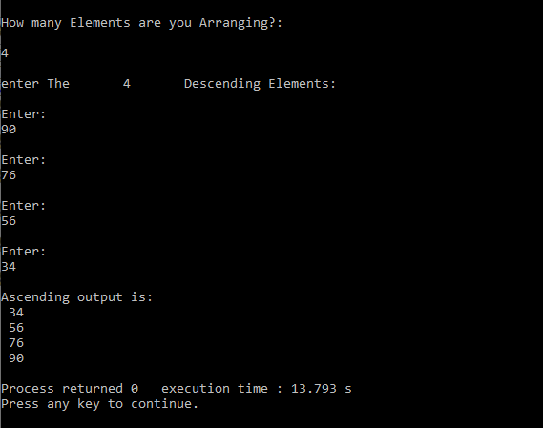

- Vector

#include <vector>

Or

#include "Vector.hpp"

- .

It creates a vector of capacity 50

- Creates a vector of capacity 0

- Elements will be stored as 2*i + 2

=> i = 0..4 => 2 , 4, 6, 8, 10

Hence Output will be 2 4 6 8 10

Output will be Nisha Tony Bobby Peter

a)
vector<int> secretList;

b)
secretList.push_back(56);
secretList.push_back(28);
secretList.push_back(32);
secretList.push_back(96);
secretList.push_back(75);

c)
for(int i=0 ; i<secretList.size(); ++i)
cout<<secretList[i] <<" ";

- Elements will be stored as 2*i + 5

=> i = 0..4 => 5 , 7, 9, 11, 13, 15, 17, 19, 21, 23

Hence Output will be 5 7 9 11 13 15 17 19, 21, 23

#include <iostream>
#include <list>
using namespace std;

int main()
{
// declaration of list container
list<int> mylist{ 1, 2, 3, 4, 5 };

// using begin() to print list
for (auto it = mylist.begin(); it !=
mylist.end(); ++it)
cout << ' ' << *it;
return 0;

- #include <iostream>
using namespace std;
int main() {
int len = sizeof(arr)/sizeof(arr[0]);
cout << "The length of the array is: " << len;
return 0;
}

- Difference between size and capacity of vector

The size of a vector represents the number of components in the vector while the capacity of a vector represents the maximum number of elements the vector can hold

PROGRAMMING EXERCISES

Solution to these exercises is in a .zip file

For example, Screenshot of solution for question 19 is here;

